Sponsoring a Historic Holly Theater Production is a prestigious, visible and valuable way to show your customers, employees and the community your leadership in supporting
QUALITY PERFORMING ARTS : HISTORIC PRESERVATION : FAMILY-FRIENDLY PROGRAMS
in the North Georgia region.

The Holly’s 2019 Season celebrates the Family.
An example of what can be accomplished when a community works together, You and Sponsors like YOU help continue to keep the Holly Theater vibrant!!

$10,000 Premier Sponsor (Exclusive, 1 per season)
- 2 Season Tickets for the 2018 Main Stage productions
- If feasible, your company's name in lights on our marquee for pre-show promotions and the full run of all the Main Stage productions
- 4 complimentary tickets to the opening night of each Main Stage production
- Credit as the SEASON Sponsor in all Marketing materials, Playbills and Posters for all Main Stage productions
- Recognition as the Season Sponsor on the Holly Website
$800 Production Sponsor (Limited availability, up to 4 for each Main Stage Production)
- Your full page ad in a prime location on the inside front cover or inside back of the production's Playbills
- Your name, logo and slogan on the hollytheater.com website
- Your name and logo included on all Holly email blasts, social media and other production advertising
- Your name and logo on the title slide in the video loop played on the Main Stage big screen
- Recognition as the Production Sponsor in our live audience address at the start of each show
- Recognition as the Production Sponsor on the Holly Website
$1,500 Title Sponsor, 2018 Main Stage Productions (Exclusive, 1 per production)
$600 Children’s Title Sponsor, 2018 Productions (Exclusive, 1 per production)
- If feasible, your company's name in lights on our marquee for pre-show promotion and the full run of the sponsored production
- 4 complimentary tickets to the opening night of the sponsored production
- Plus all the benefits listed under the Production Sponsor

$3,000 Children’s Premier Sponsor (Exclusive, 1 per season)
- 2 Season Tickets for the 4 Children’s stage productions
- If feasible, your company's name in lights on our marquee for pre-show promotion and the full 2018 run of the Children’s Stage productions
- 4 complimentary tickets to the opening night of each Children’s stage production
- Credit in all Marketing materials, Playbills and Posters for all Children’s Stage productions
- Recognition as the Children’s Season Sponsor on the Holly Website

$400 Concert Sponsor (Exclusive, 1 per concert)
- Your company's name on posters for pre-concert promotions
- Your name, logo and slogan on the hollytheater.com website
- Your name and logo included on all Holly email blasts, social media and other production advertising
- Two complimentary tickets to one concert
- Your full page ad in a prime location on the inside front cover or inside back of the concert's Playbill (see Note below)

Note: If no Playbill is printed, there will not be any Playbill advertising available, but there will be a pre-show announcement of the sponsor

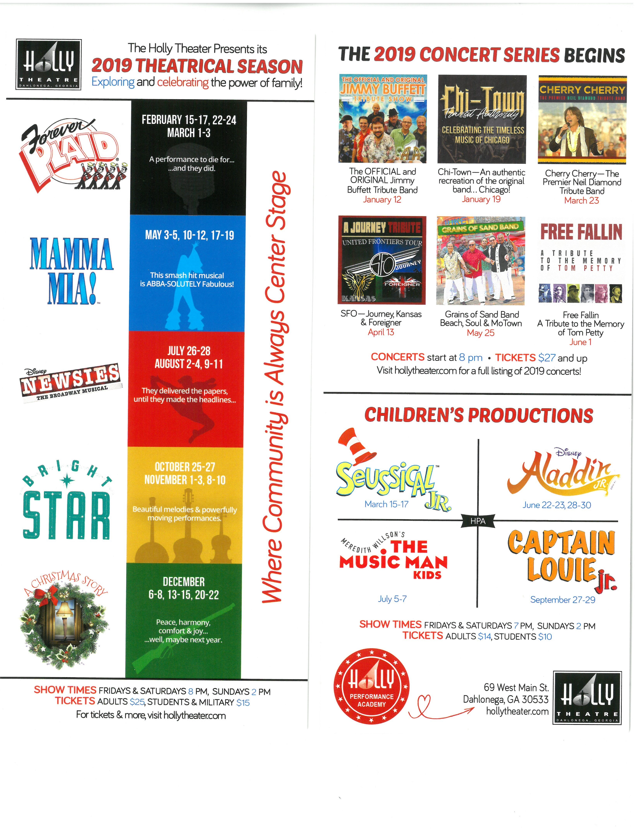

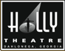
Yes! Count me in as a SPONSOR for the Holly Theater's
2019 Season celebrating the family!

AGREEMENT

I / my company would like to take a leadership role in supporting:
Quality Performing Arts : Historic Preservation : Family-friendly programs
in Dahlonega and the surrounding communities in the North Georgia region.

Check __Here if Interested in a Premier Season Sponsorship ($10,000 for the season —
you will be contacted)
Check __Here if Interested in a Children’s Premier Season Sponsorship ($3,000 for the season--you will be contacted)
Please list me / my company as the Title Sponsor for:
Check __All 5 Main Stage Productions ($7,500)(or)
Production ($1500) #1: _______________________________________________
Production ($1500) #2: _______________________________________________
Production ($1500) #3: _______________________________________________
Check __All 5 Children’s Productions ($3,000) (or)
Production ($600) #1: _______________________________________________
Production ($600) #2: _______________________________________________
Please list me / my company as the Production Sponsor for:
Check __All 5 Main Stage Productions ($4,000)(or)
Production ($800) #1: _______________________________________________
Production ($800) #2: _______________________________________________
Production ($800) #3: ______________________________________________
__ Concert(s) ($400)on Dates:___________________________________________
__________________________________________________________________________________

Amount due for Title Sponsorship ($1500 per Production) $____________

Amount due for Children’s Title Sponsorship ($600 per Production) $____________

Amount due for Production Sponsorship: ($800 per Production) $____________

Amount due for Concert Title Sponsorship ($400 per Concert): $____________

Total amount due: $____________

_______________________________________ _______________________________________
Business name Representative name (print)

_______________________________________ _______________________________________
Business Address Line 1 Business Address Line 2

_______________________________________ ______________ _________________
City State ZIP

________________________________________ ______________ ________________________________
eMail Phone(s)

_______Business Representative Initial (Sign on the last page, over/)

2019 Camera-ready Logo and Ad Guidelines

- Formats: JPEG, TIF, GIF
- Size:
  - Full-page: 5" x 8" vertically oriented
  - Half-page: 5" x 3.5" horizontally oriented
  - Quarter-page: generally business card size
- Deadline: Finished (camera-ready) logos / ads must be submitted 21 days before the week of the show for which the Playbill is being printed (see below).

Email graphic files to: info@HollyTheater.com

Submission and Payment Deadlines for 2019

Main Stage Productions
- Forever Plaid – January 25th
- Mamma Mia – April 12th
- Newsies - July 5th
- Bright Star - October 11th
- A Christmas Story - November 22nd

Children’s Productions
- Seussical – March 1st
- Captain Louie – March 22
- Aladdin – June 7th
- The Music Man – June 21st
- Disney’s Frozen, Jr. - September 13th

All Concerts: Wednesday two weeks prior to performances
(see hollytheater.com for full schedule)
Example:
Cherry Cherry (scheduled for Saturday, Mar. 23)—deadline March 6th

___________________________________________________ _________________________
Business Representative Signature Date

Send Agreement to: Holly Theater, 69 West Main St, Dahlonega, GA 30533
Telephone 706-530-516

